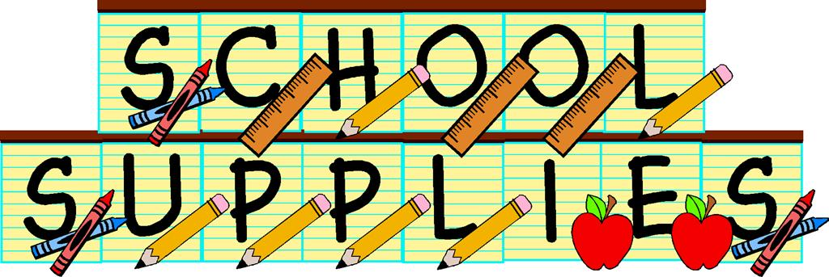
MRS. BENTLEY’S CLASS
2016-2017

Classroom Sharing Items:
1 box of tissues
1 bottle of school glue
1 nonperishable snack (crackers, pretzels, etc…) to share
Gallon size Ziploc bags

Classroom Personal Items:
(I will provide a pencil box for each student to keep their own supplies in)
Several glue sticks
1 box of Crayola Twistable crayons (They last longer)
1 box of Crayola Twistable colored pencils (They last longer too)
Handheld pencil sharpener
2 pocket folder (the plastic ones last longer)
This will be their take home folder that we will use daily
1 one inch binder
Small package of sheet protectors
Personal earbuds for the computers (optional)

(* You do not need scissors, paper, regular pencils, or any kind of pencil case.)
A backpack without wheels on it. (They don’t fit in the lockers)

